MLOps CI/CD Framework implementation Details

Table of Contents
- Repository Template Structure
- Branching Strategy
  - Primary Branches
  - Dev Deployment Workflow
  - QC-UAT Testing Workflow
  - Production Deployment Workflow
  - Hotfix Workflow
- ChatOps Integration in CI/CD
- Prod vs. QC Check for Deployment Validation
- Step Ladder Approach for SageMaker Pipeline Execution
  - Architecture Overview
  - How It Works
  - Jupyter Notebook Converter
  - Passing variables between Sage Maker pipeline steps
  - Configuration and Usage of Runtime and Environment Variables
- Global Utilities and Data Elements Process
  - Architecture Overview
  - Configuration and Usage of Global Utilities in Custom Pipelines
  - Configuration and Usage of pipeline name in Custom and deafult Pipelines
  - Usage of Global Utilities in Notebooks
  - Comparison Between Traditional and Decoupled Global Utilities Approach
  - Advantages

1. Repository Template Structure
A GitHub repository template called spc-com is used for all projects to maintain consistency and organization.

Repository Structure Overview
Each folder has a specific purpose:
- .github/workflows/ → Contains CI/CD workflow files for automation.
- certificates/ → Stores certificates required for SageMaker pipelines.
- config/ → Holds ML pipeline configuration files and environment variables.
- data/ → Contains project-specific data like SQL queries or datasets.
- doc/ → Includes documentation related to the project.
- notebooks/ → Contains Jupyter notebooks related to the project.
- reference/ → Stores knowledge base articles and reference materials.
- reports/ → Holds evaluation reports, figures, and analysis results.
- scripts/ → Includes ChatOps scripts used in the ML pipeline.
- src/ → Main source code folder.
  - src/resources/ → Stores common utilities used across projects.
  - src/default/ → Contains Jupyter notebooks converted python files.
  - src/custom/ → Python files for creating a custom SageMaker pipeline.
- test/ → Holds test scripts for validating ML models.
- .version → Defines the project’s CI/CD version.
- CODEOWNERS → Specifies who has permission to modify different files.

2. Branching Strategy
A proper branching strategy is followed to manage development, testing, and deployment.
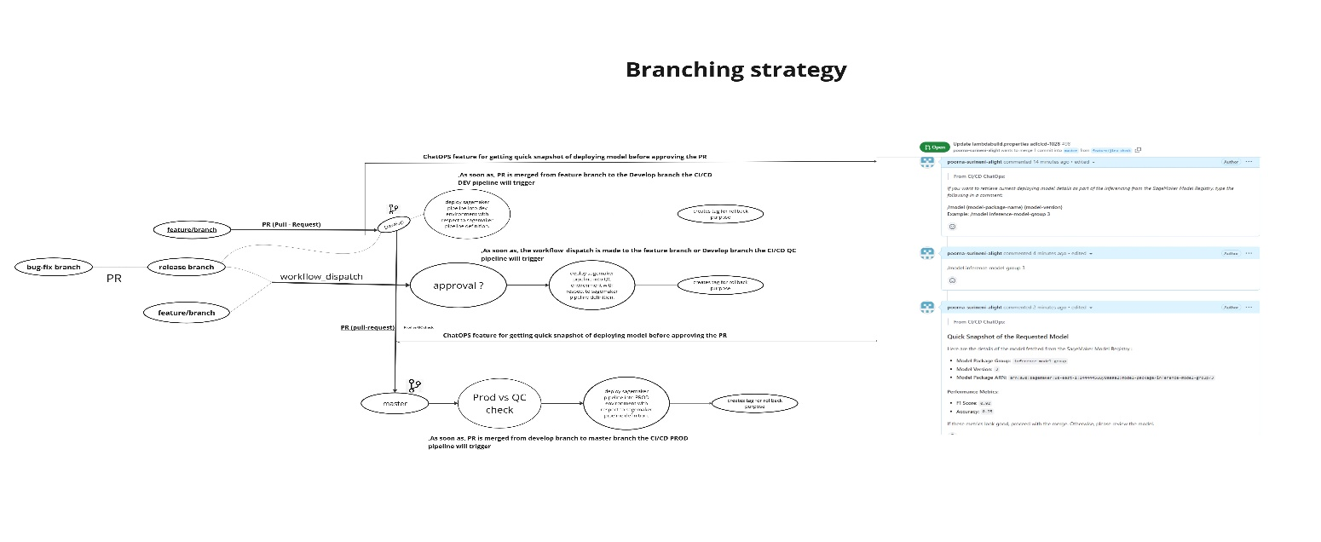
Miro Board link: https://miro.com/app/board/uXjVLVVm72A=/?share_link_id=7777

Primary Branches
- master – Final branch where only tested and production-ready code is merged.
- develop – Active development branch where new features are added.

Dev Deployment Workflow
- Developers create a feature branch from develop.
- Once changes are done, they create a pull request (PR) to merge into develop.
- The CI/CD workflow runs tests and validates the changes before merging.
- Once merged, the code is automatically deployed to the Dev environment.

QC-UAT Testing Workflow
- A release branch is created from develop for testing.
- A bug-fix branch is created from the release branch if any issue is found.
- After fixing the issues, the changes are merged back into the release branch.
- The QC deployment is triggered using a workflow dispatch.
- Deployment to QC requires approval before going live.
- Once QC testing is successful, the release branch is merged back into develop.

Production Deployment Workflow
- Once testing in QC is completed, changes from develop are merged into master.
- Merging into master automatically deploys the changes to production.
- A tag is created to track the deployment.

Hotfix Workflow
- A hotfix branch is created from master for urgent fixes.
- Any changes committed to the hotfix branch are directly deployed to production.
- The developer must merge the hotfix branch back into develop and master to keep everything in sync.

3. ChatOps Integration in CI/CD
ChatOps allows developers to run automation commands directly from GitHub PRs instead of running scripts manually.

How ChatOps Works?
- A developer enters a ChatOps command in a PR comment.
- GitHub workflows detect the command and run the corresponding script.
- The backend executes the script from the chatops/ directory.
- Results are posted as a reply in the PR.

ChatOps Directory Structure
- Scripts/chatops/model_chatops.py → Runs /model command to get model details.
- Scripts/chatops/evaluate_chatops.py → Runs /evaluate command to check test results.

Example ChatOps Commands
- /model {model-name} {version} → Fetches model version, F1-score, and accuracy.
- /evaluate {model-name} → Runs tests and posts results in the PR.
Advantages of ChatOps:
- Improves transparency by providing model evaluation insights directly in the PR.
- Ensures that all stakeholders can review model performance metrics before final deployment.

- Helps with easy troubleshooting.
• Suppose a model was deployed to production a long time ago, and someone wants to check its evaluation metrics.
• Instead of searching through logs or the SageMaker console, they can simply go to the PR and review the evaluation metrics right there.
So, this is how ChatOps helps simplify the ML deployment process, improves visibility, and makes troubleshooting much easier!”

4. Prod vs. QC Check for Deployment Validation
Before deploying code to production, a Prod vs. QC Check ensures that the commit was tested in QC first.

How It Works?
- When code is merged from develop to master, the CI/CD pipeline checks if the commit was already tested in QC.
- If the commit exists in QC, the deployment proceeds.
- If the commit was not tested in QC, deployment is blocked.

Why This Is Important?
- Prevents untested code from going live.
- Ensures production is always stable.
- Reduces risks of failures in production.

5. Step Ladder Approach for SageMaker Pipeline Execution

Architecture Overview
The MLOps pipeline follows a Step Ladder Approach, which means each step is processed one by one based on the configuration file (sagemaker-pipelines.json) stored in the config directory.
Whenever a developer commits a Jupyter Notebook into the src/notebooks/ folder, the backend system reads the pipeline configuration and runs each step accordingly.
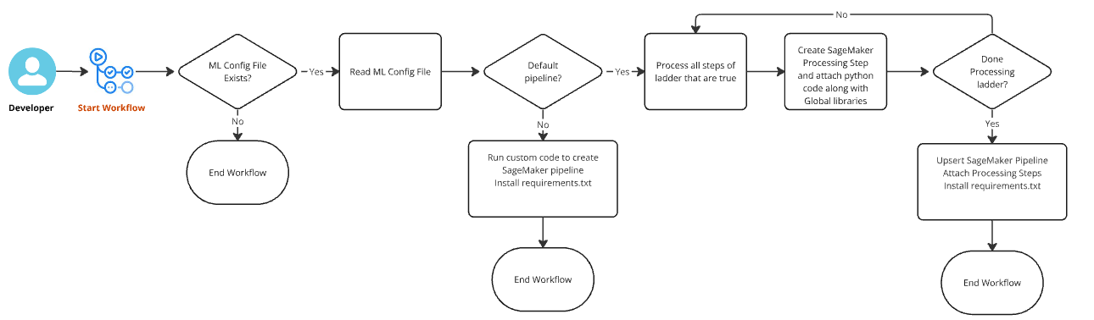
Miro board link: https://miro.com/app/board/uXjVLELW33E=/?share_link_id=8942793

Pipeline Configuration (sagemaker-pipelines.json)
This JSON file defines how the ML pipeline should run.
Example structure:
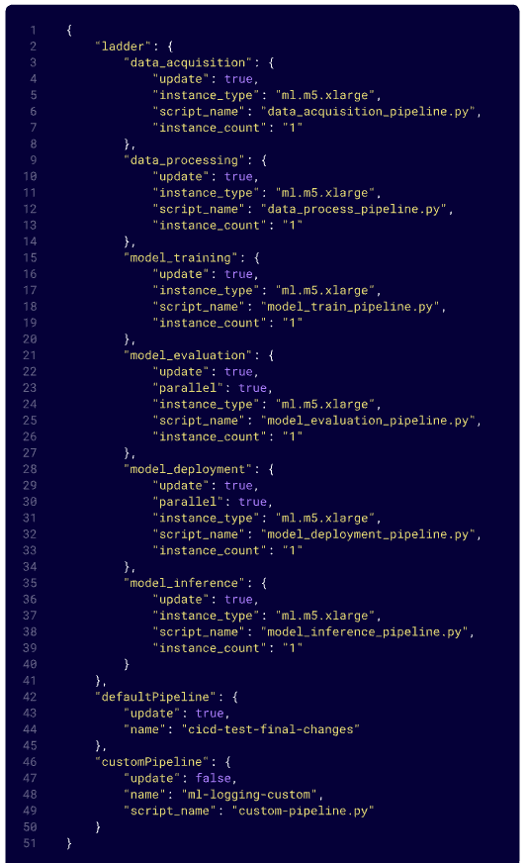

How It Works?
- The system checks if sagemaker-pipelines.json exists in the config directory.
  - If not found → End of workflow.
  - If found → Read the config file.
- If the "update": true" attribute is set for customPipeline, the below steps will be executed.
  - Requirements.txt will be installed.
  - The python program defined by script_name will be executed, and the workflow will end.
- If the "update": true" attribute is set for defaultPipeline, the below steps will be executed.
  - It processes all steps marked as "update": true".
  - For each step:
    - Requirements.txt will be installed.
    - The python program defined by script_name will be attached to the processing step.
    - Global libraries\supporting files are attached to the processing step.
    - If "parallel": true" is specified for two sequential steps, a parallel step will be created in the SageMaker pipeline. Once all parallel steps have completed, the next step will execute.
  - Once all steps are processed, the SageMaker pipeline is created.
Key Notes:
- Custom Pipeline Scripts: Place custom Python SDK scripts for the custom pipeline in `src/custom`.
- Default Pipeline Scripts: Place custom python scripts for the default pipeline in `src/default`.

Jupyter Notebook Converter:

When a data scientist commits changes to the `notebook` folder, the notebook converter automatically executes, converting the Jupyter Notebook into a Python script. The system handles multiple scenarios:

- If a notebook file is uploaded to the notebook folder, it is converted into a Python script and stored in the src/default folder.
- If a notebook file is updated, the corresponding script in the src/default folder is also updated.
- If a notebook file is deleted from the notebook folder, the corresponding script in the src/default folder is also removed.
- If a script is deleted from the src/default folder, it will be identified with its corresponding notebook file, and a new script will be recreated.
The notebook converter only runs when a commit happens on the feature branch or the release branch, ensuring that conversions are performed only during active development and controlled releases, preventing unnecessary updates in stable branches.

Passing Variables Between Sagemaker Pipeline Steps:

- The system provides an inbuilt function param_handler for passing variables between steps. For example, if a feature engineering step generates a feature group name that needs to be used in the model training step, `param_handler` can store this information in an S3 bucket and make it available in subsequent steps, ensuring smooth data flow within the pipeline. You just need to pass your variables into this param
- If a parameter is defined in step 1, it is stored in an S3 bucket under shared_variable.json and it is accessible in subsequent steps automatically.
Example Usage:
If the feature_group_name and model variables needs to be accessed in the model training step but originates from the data processing step:
Use the format below to pass variables into the param_handler. Simply provide the variables as a key-value pairs. If multiple values are needed, separate them with a comma.
param_handler(feature_group_name = “feature_cicd”, model = “v1”)

These values can then be retrieved in the model training step using the same keys.

Configuration and Usage of Runtime and Environment Variables:
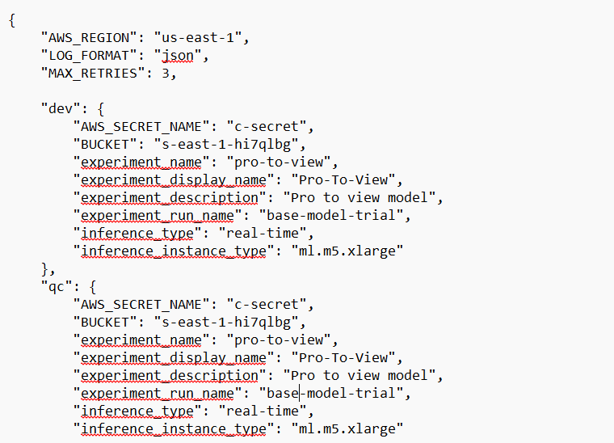
- Store runtime variables in rc.json under config directory.
- To access an environment variable in a notebook or Python script use os.environ.get():

import os
os.environ.get("VARIABLE_NAME")

- This method applies to both default and custom pipelines.

6. Global Utilities and Data Elements Process

Summary
The ML Global Utilities and Data Elements approach simplifies a data scientist’s work by automating common steps like fetching secrets, establishing database connections, exporting data to Athena, registering models in the model registry, managing feature groups, and pushing data to a feature store—allowing them to focus on building models while leveraging this pre-built backend process for seamless integration and efficiency. These utilities can be utilized across different projects, ensuring consistency and scalability.

Architecture Overview
- The CI/CD pipeline investigates the data and src/resources/ directories and process each file present in it.
- Global utilities are stored in src/resources/.
- Project-specific data elements are stored in the data directory.
- Certificates are stored in the certificates directory
- Requirements.txt is stored on the root and will be applied to both default and custom pipelines.
- These files are then pushed to the SageMaker session under opt/ml/processing/ path.
  - opt/ml/processing/certificates -> certificates
  - opt/ml/processing/requirements -> requirements.txt
  - opt/ml/processing/utilities -> global python utilities
  - opt/ml/processing/data -> project data elements
  - opt/ml/processing/cicd -> cicd python utilities
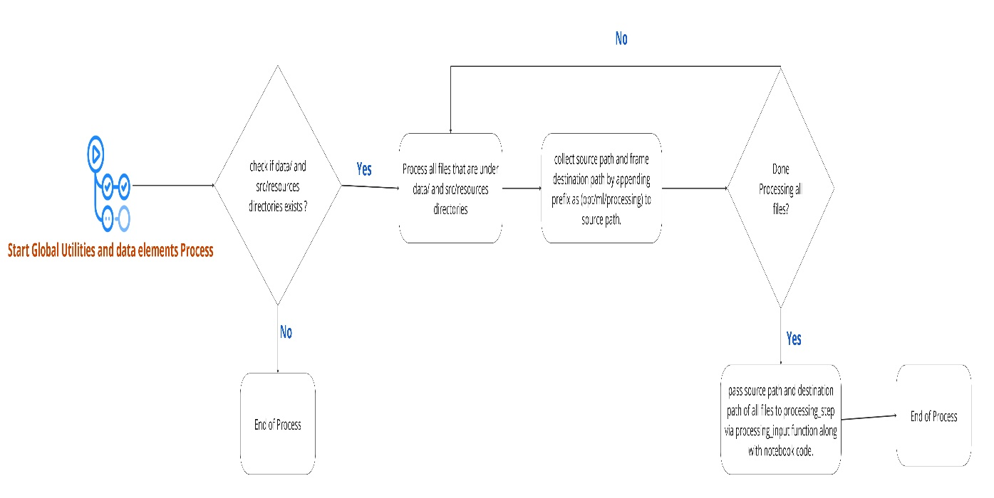

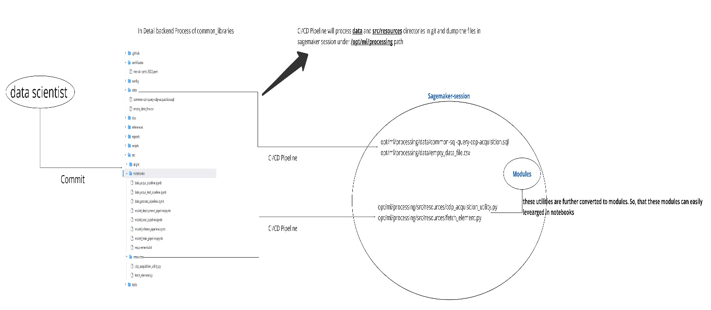
Miro Board link: https://miro.com/app/board/uXjVLnSBFgE=/?share_link_id=422402

Custom Pipeline Configuration and Global Utilities Usage
By default, global utilities are not directly available to the custom pipeline. To leverage global utilities in a custom pipeline, you need to use the following command :
os.environ.get(pipeline_artifacts)
This command returns a list of mappings, where each mapping contains:
utilities: s3://-com- /cicd/{pipeline_name}/utilities,
data:s3://-com- /cicd/{pipeline_name}/data,
requirements:s3://-com- /cicd/{pipeline_name} /requirements/requirements.txt,
certs:s3://-com- /cicd/{pipeline_name}/certificates/rhel-all-certs-2022.pem,
cicd:s3://-com- /cicd/{pipeline_name} /cicd/cicdsetup.py
Utilities Corresponding S3 path
Data Respective s3 path
Certificates Respective s3 path
Requirements Respective s3 path
CICD Respective s3 path
These mappings should be utilized in each processing step as a processing inputs. By doing so, you can effectively leverage both:
Global utilities functionality
Param handler to pass variables between steps
Configuration and Usage of Pipeline name in Custom and Default pipelines:
To retrieve the pipeline name in a custom and default pipelines, use:
os.environ.get("pipeline_name")
The pipeline name follows a standard naming convention starting with adl-com-{environment_name} enforced by the backend. But for the custom pipelines, If the naming convention is not followed correctly, you will not be able to create the pipeline successfully.
Key Notes:
For default pipelines automatically standard naming convention is used, But for the custom pipelines, If the naming convention is not followed correctly, you will not be able to create the pipeline successfully.

Usage of Global Utilities in Notebooks
- Global utilities like fetching AWS secrets, getting connection parameters, and ODBC connections are stored in src/resources/.
Example:
from cdp_acquisition_utility import fetch_aws_secrets, get_connection_params, establish_odbc_connection
- This avoids writing the same code multiple times in every project.

Comparison Between Traditional and Decoupled Global Utilities Approach
- Traditional Approach:
  - Each project writes automated utilities for tasks like DP_acquisition_utility (fetching aws secrets, building connection params, establishing pyodbc connection), DP_export_utility (wrangler_s3_parquet), Athena_export_utility (Export data to athena catalogue).
  - Leads to repetitive code across projects.
- Decoupled Global Utilities Approach:
  - Now these automated utilities are stored once in a repository at src/resource directory.
  - Projects import the utilities into notebooks instead of rewriting them.

Advantages
- Centralized control from a template repository.
- Scalability of global utilities.
- Versioning support for project-specific data and utilities.
- Data scientists can focus on model building, not repeating setup code.
- Faster debugging and troubleshooting due to centralized utility management.

